Azure Storage Analytics Viewer User Guide

*2011/11/22 Updated*

## Enable Azure storage analytics

By default azure storage analytics is disabled. User need enable azure storage analytics manually.

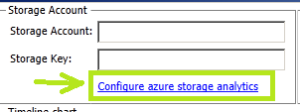

Cerebrata provides free tool to configure the azure storage analytics

<http://www.cerebrata.com/Blog/post/Cerebrata-Windows-Azure-Storage-Analytics-Configuration-Utility-A-Free-Utility-to-Configure-Windows-Azure-Storage-Analytics.aspx>

## Check Azure storage Metrics and logs

1. Input storage account name and key
2. Select time range. By default, it select one day before now.
3. Select the storage type which you want to view.
4. Click button to metrics data

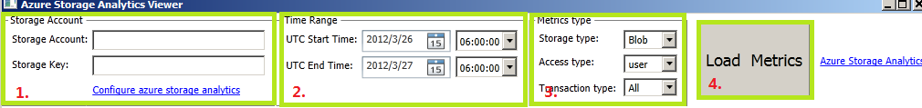

1. After loading metrics, the chart would show the data. Right click chart to add/remove Series

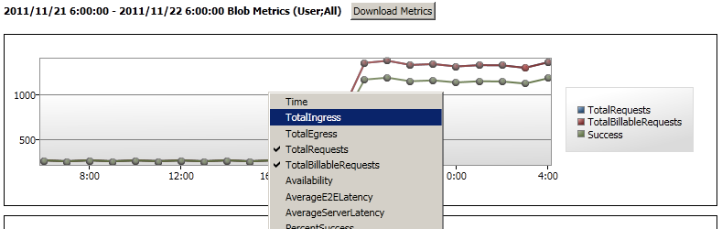

1. Click “Download Metrics” to save metrics data to local csv file.
2. Click the datapoint on chart, all metrics properties will show on right side panel.

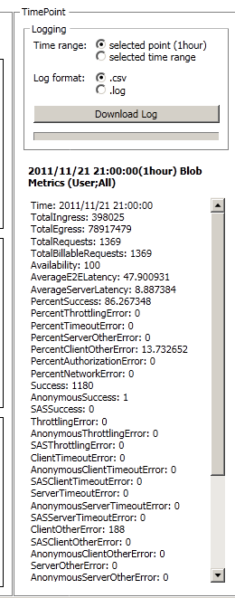

1. Click “Download Log” to download transaction log and save to local csv file